SKILLBRIDGE – PLACEMENT PREPARATION PORTAL

SUBMITT : YUVA INTERNSHIP PROGRAM
INTERNSHIP ROLE : JUNIOR FULL STACK DEVELOPER INTERN
SUBMITTED BY : MOHANAPRIYA R
SUBMISSION : WEEK 2 TASK
– PROJECT PLANNING &
SYSTEM ARCHITECTURE
DATE : SEPTEMBER 2026

1. INTRODUCTION

SkillBridge is a web-based Placement Preparation Portal designed to help students improve their employability skills and prepare effectively for campus placements. The platform provides study materials, aptitude tests, coding practice sessions, progress tracking, and performance analysis in a centralized environment.
The system aims to bridge the gap between academic learning and industry requirements by offering a structured preparation platform. Students can monitor their performance and identify areas for improvement, while administrators can manage educational content and assessments efficiently.

2. PROBLEM STATEMENT
Many students face challenges during placement preparation due to scattered learning resources and lack of progress tracking. There is a need for a centralized platform that combines study materials, aptitude tests, coding practice, and performance monitoring.

3. OBJECTIVES
- Provide centralized placement preparation resources.
- Conduct online aptitude assessments.
- Track student progress and performance.
- Improve placement readiness.
- Enable administrators to manage educational content.
- Support coding and technical skill development.

4. PROJECT SCOPE
The SkillBridge Placement Preparation Portal is designed for students, educational institutions, and placement training departments. The system provides a centralized environment for learning, assessment, and performance tracking. It supports both students and administrators through dedicated modules and helps improve placement readiness through structured preparation activities.
Target Users
- Students
- Placement Coordinators
- Training Departments
- Educational Institutions

5. KEY FEATURES
Student Features
- User Registration and Login
- Access Study Materials
- Attend Aptitude Tests
- View Test Results
- Track Performance Progress
Admin Features
- Manage Users
- Upload Study Materials
- Create and Manage Tests
- Monitor Student Performance
- Generate Reports

6. FUNCTIONAL REQUIREMENTS
Student Module
The student module allows users to:
- Register an account
- Login securely
- Access learning materials
- Attempt aptitude tests
- View scores and results
- Track preparation progress
Admin Module
The admin module allows administrators to:
- Manage user accounts
- Upload and update study materials
- Create aptitude tests
- Add questions and answers
- Monitor overall platform activity

7. NON-FUNCTIONAL REQUIREMENTS
Performance
The system should provide fast response times and smooth user experience.
Security
Passwords should be securely stored and authenticated.
Scalability
The application should support increasing numbers of users.
Availability
The platform should be available 24/7.
Usability
The interface should be simple, responsive, and user-friendly.
Reliability
The system should provide consistent and accurate results.

8. USER FLOWCHART
The following flowchart illustrates the complete user journey within the SkillBridge Placement Preparation Portal.
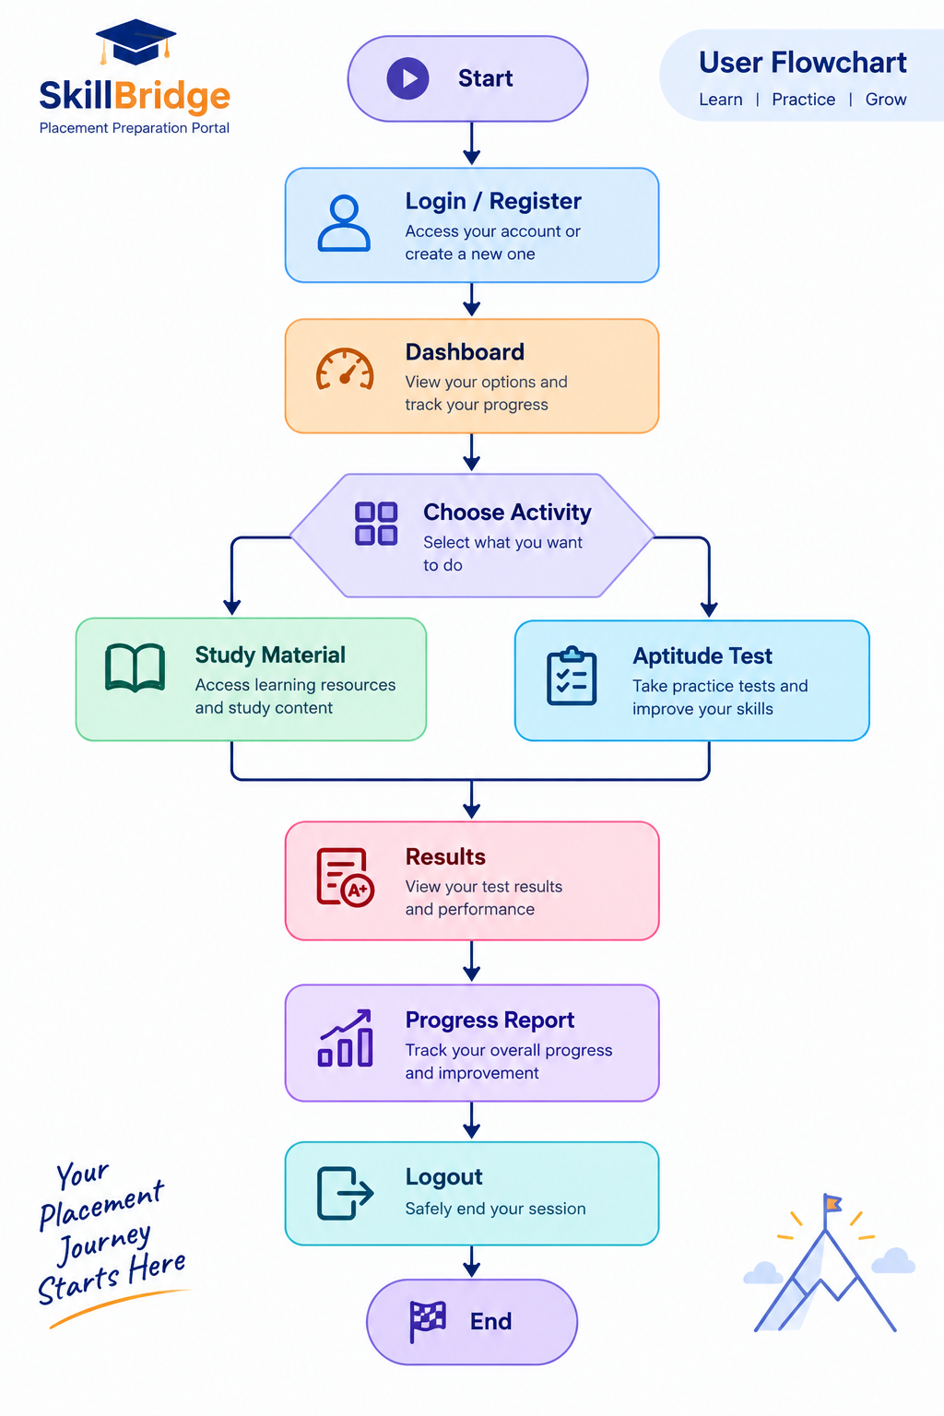
Figure 1 :USER FLOWCHART
9. WIREFRAME DESIGN
Wireframes are low-fidelity visual representations of the user interface. They help define the structure, navigation, and user experience of the SkillBridge Placement Preparation Portal before actual development begins.
9.1 Login Page Wireframe
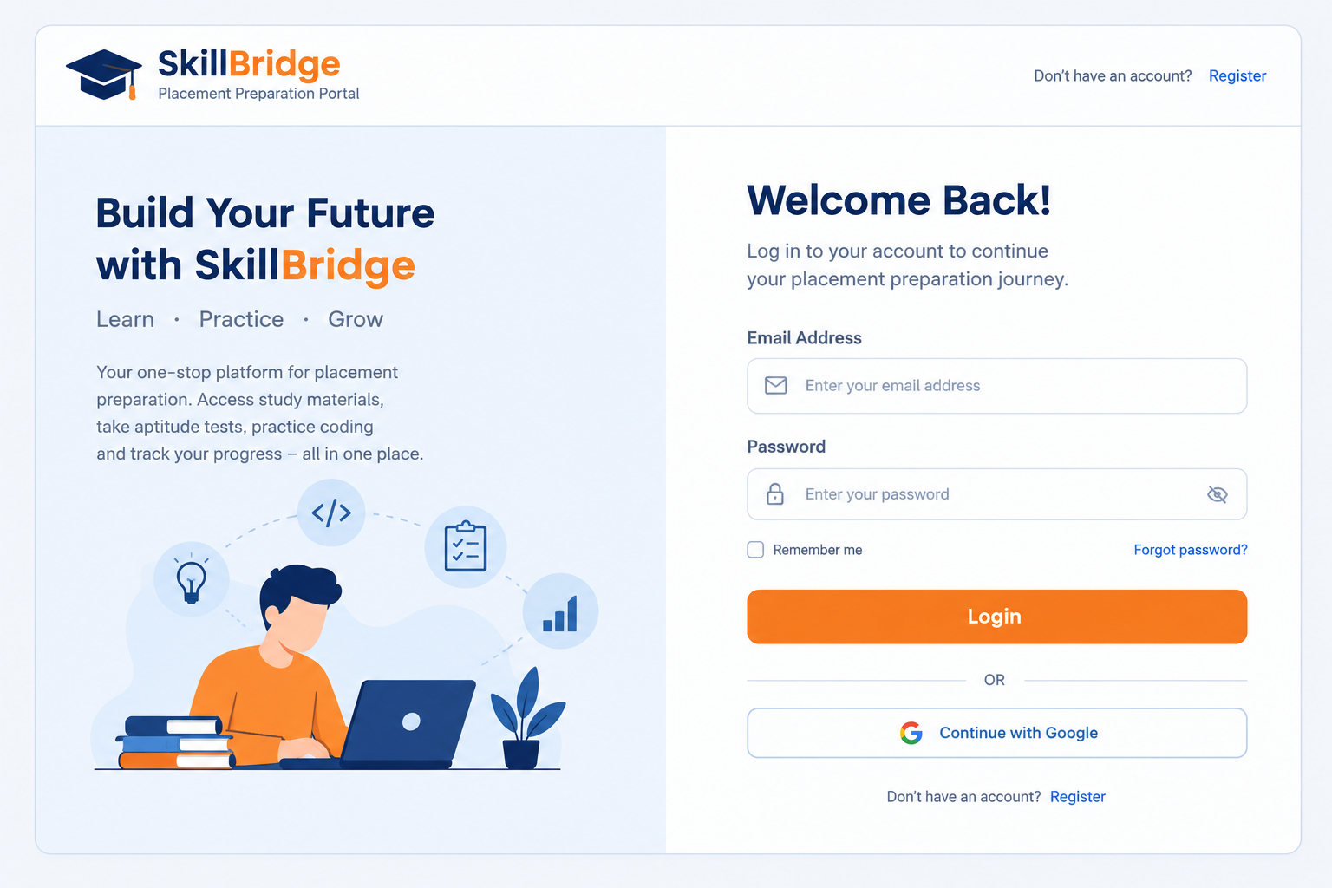
Figure 2: Login Page Wireframe

9.2 Dashboard Wireframe
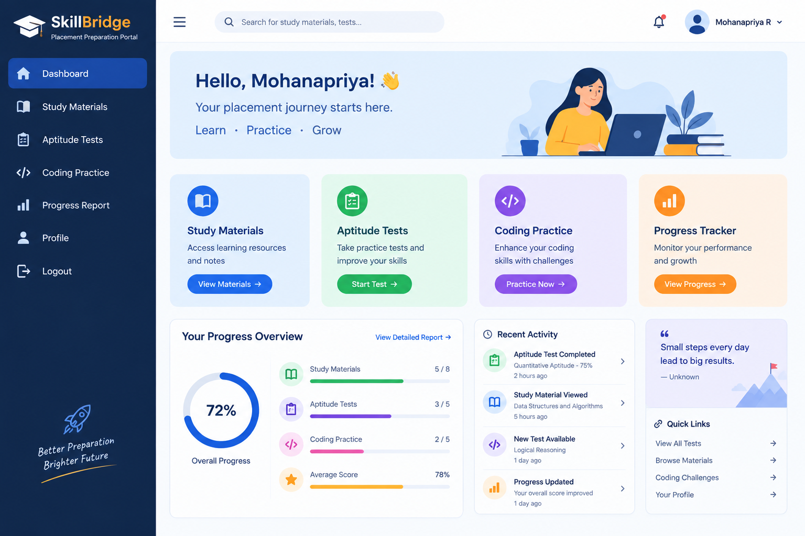
Figure 3: Dashboard Wireframe
9.3 Aptitude Test Page Wireframe
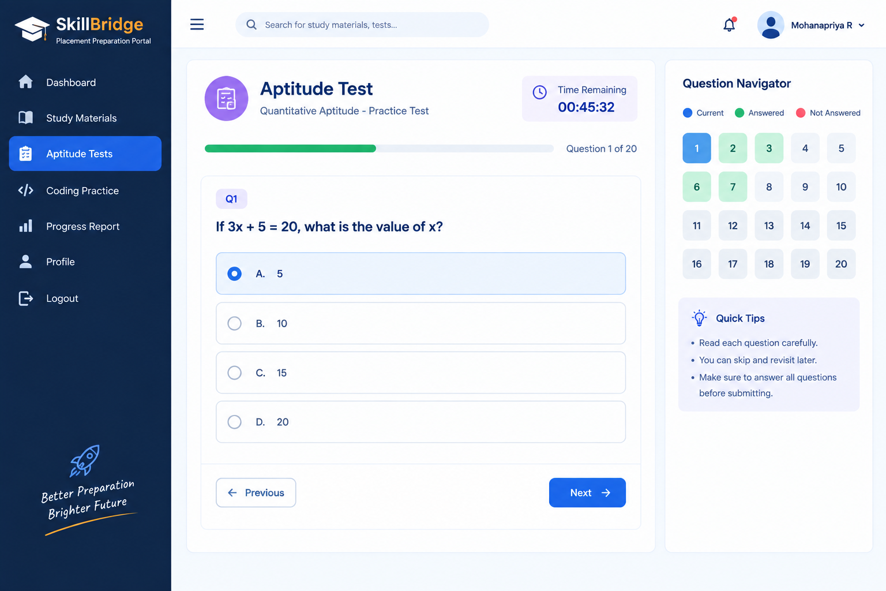
Figure 4: Aptitude Test Page Wireframe

9.4 Progress Report Page Wireframe
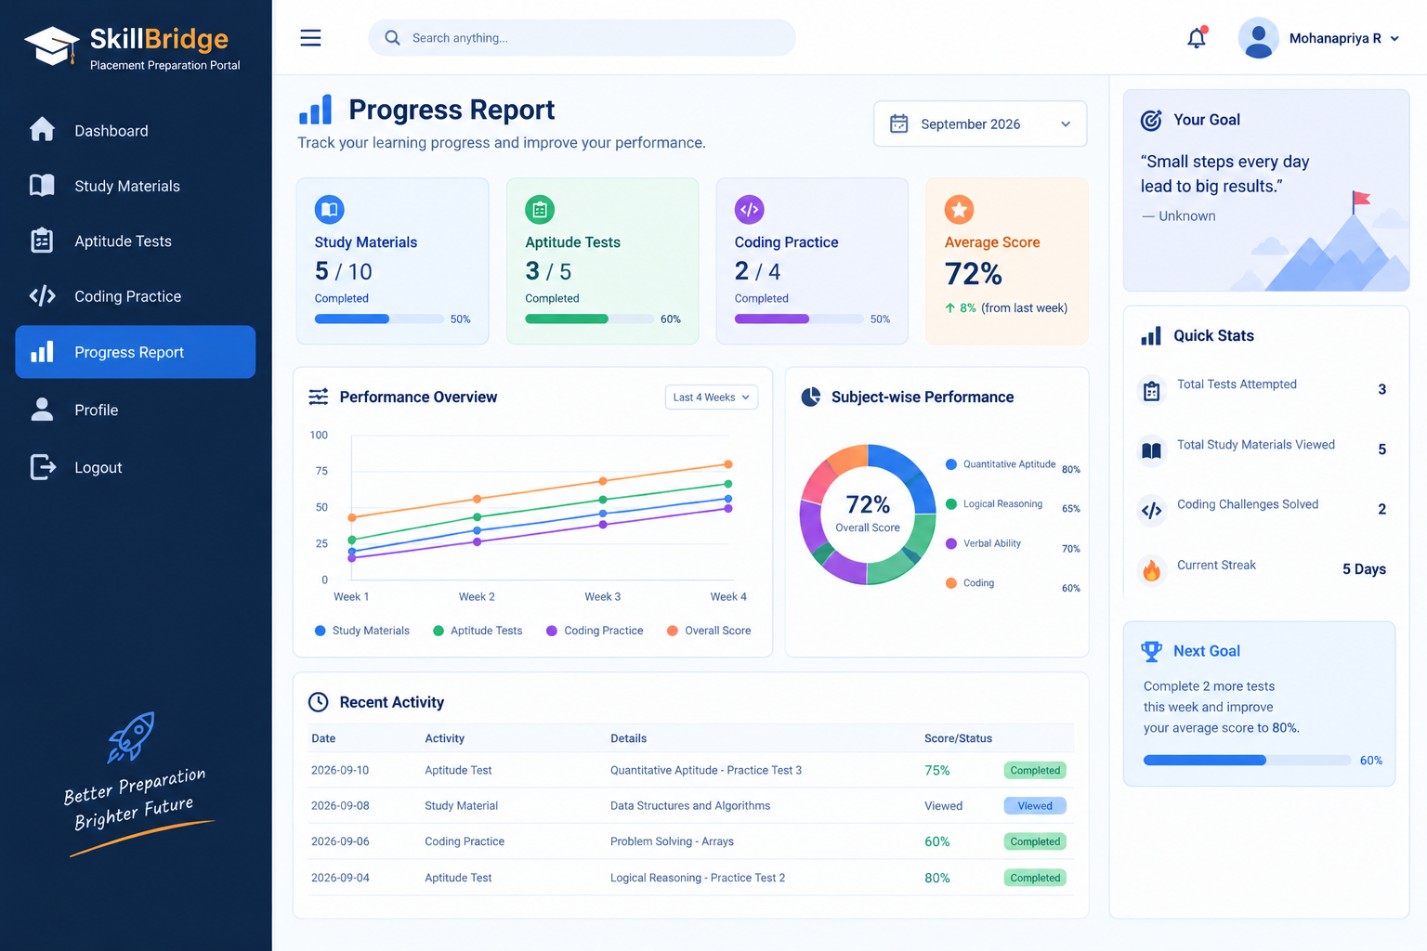 Figure 5: Progress Report Wireframe

10. SYSTEM ARCHITECTURE
The SkillBridge system follows a three-tier architecture consisting of the Presentation Layer, Business Logic Layer, and Database Layer. This architecture improves scalability, maintainability, and performance by separating responsibilities across different components.
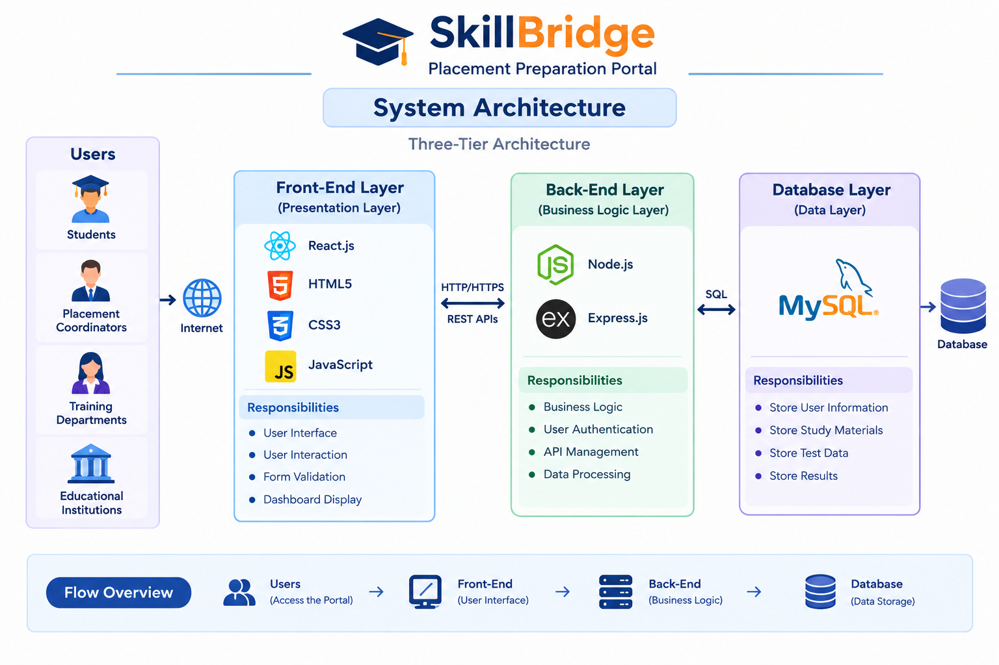
Figure 6: SkillBridge System Architecture
Architecture Components
Front-End Layer
Technologies:
- React.js
- HTML5
- CSS3
- JavaScript
Responsibilities:
- User Interface
- User Interaction
- Form Validation
- Dashboard Display
Back-End Layer
Technologies:
- Node.js
- Express.js
Responsibilities:
- Business Logic
- User Authentication
- API Management
- Data Processing
Database Layer
Technology:
- MySQL
Responsibilities:
- Store User Information
- Store Study Materials
- Store Test Data
- Store Results

11. DATABASE SCHEMA
USERS TABLE
Field Name | Data Type
user_id | INT
name | VARCHAR
email | VARCHAR
password | VARCHAR
role | VARCHAR
MATERIALS TABLE
Field Name | Data Type
material_id | INT
title | VARCHAR
description | TEXT
TESTS TABLE
Field Name | Data Type
test_id | INT
title | VARCHAR
total_marks | INT

QUESTIONS TABLE
Field Name | Data Type
question_id | INT
test_id | INT
question_text | TEXT
RESULTS TABLE
Field Name | Data Type
result_id | INT
user_id | INT
test_id | INT
score | INT

12. ENTITY RELATIONSHIP DIAGRAM (ER DIAGRAM)
The ER Diagram represents the relationship between users, tests, questions, study materials, and results. It helps visualize how data is connected within the SkillBridge Placement Preparation Portal.
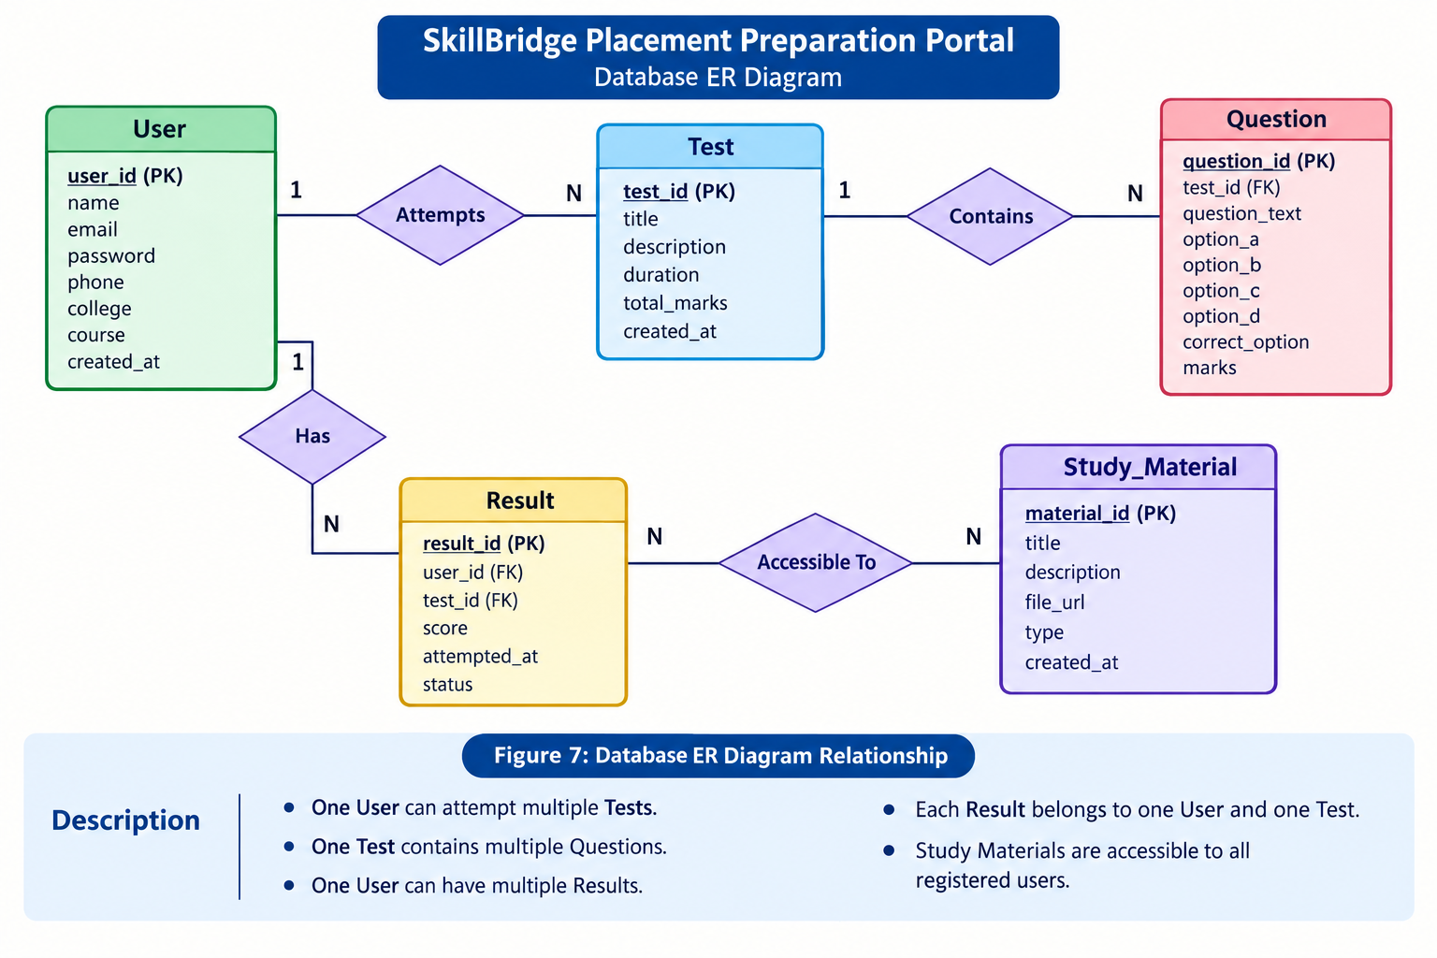
Figure 7: Database ER Diagram
Relationship Description
- One User can attempt multiple Tests.
- One Test contains multiple Questions.
- One User can have multiple Results.
- Each Result belongs to one User and one Test.
- Study Materials are accessible to all registered users.

13. API DESIGN
RESTful APIs are used to facilitate communication between the front-end and back-end components of the application.
Authentication APIs
Method | Endpoint | Description
POST | /register | Register new user
POST | /login | User login
GET | /profile | Get user profile
Study Material APIs
Method | Endpoint | Description
GET | /materials | Fetch materials
POST | /materials | Add materials
Test APIs
Method | Endpoint | Description
GET | /tests | Fetch tests
POST | /submit-test | Submit test
GET | /results | View results

14. TECHNOLOGY STACK
Front-End Technologies
- React.js
- HTML5
- CSS3
- JavaScript
Back-End Technologies
- Node.js
- Express.js
Database
- MySQL
Development Tools
- Visual Studio Code
- Git
- GitHub
- Canva

15. DESIGN RATIONALE
React.js
React.js was selected because it provides reusable UI components, fast rendering, and efficient state management.
Node.js
Node.js enables scalable server-side development and handles multiple requests efficiently.
Express.js
Express.js simplifies routing, middleware integration, and API development.
MySQL
MySQL provides reliable relational database management and ensures structured data storage.
REST APIs
RESTful APIs offer standardized communication between front-end and back-end services.
Three-Tier Architecture
The three-tier architecture improves maintainability, scalability, and security by separating presentation, business logic, and data layers.

16. FUTURE ENHANCEMENTS

The following features can be added in future versions:
- AI-Based Resume Analysis
- AI Mock Interview Module
- Job Recommendation System
- Company-Specific Preparation Plans
- Real-Time Coding Challenges
- Certificate Generation
- Email Notifications
- Performance Analytics Dashboard

17. CONCLUSION

SkillBridge – Placement Preparation Portal is designed to provide a centralized platform for students preparing for campus placements. The proposed architecture supports scalability, security, and maintainability while ensuring a user-friendly experience. Through study materials, aptitude assessments, and progress tracking, the platform helps students improve their placement readiness and achieve better career opportunities. The project planning and architecture design presented in this report provide a strong foundation for future development and deployment.

